**Tableau II**

**Activity guide**

Reference: “Do More with Views”

<http://onlinehelp.tableau.com/current/pro/online/mac/en-us/more_with_views_overview.html>

This workshop is designed for people who already have a basic familiarity with using Tableau, which is a data visualization software freely available for download. Introductory aspects, such as how to make and edit basic types of visualizations, of Tableau are covered in our introductory Tableau workshop.

In this workshop, we will cover the following skills using Tableau:

* Grouping
* Bins
* Calculated fields
* Filtering
* Using Multiple Measures
* Selected Highlighting
* Quick Table Calculations
* Combination Charts

**Guiding Research Questions:**

* Where are demolitions happening in Raleigh? Patterns?
* What are the main types of demolitions happening?
* How have the costs changed over time?
* How have fees changed over time?

## **Getting Started**

**Load in a data set: Building_Permits.csv from the folder at go.ncsu.edu/tableau2**

Download **Building_Permits.csv** to your computer from the Google Drive data folder

Open Tableau Public

Connect to a Data set

Choose Text file

Select Building_Permits.csv, click Connect

When it loads, check to make sure the data is structured properly and the data types are correct at the top of each column.

Click on Sheet1

## **Easy Bar chart (warmup)**

We’ll make a quick bar chart. This will visualize which zip codes have the most demolitions.

Drag Zip to Columns (Columns is your X Axis)

Drag Number of Records to Rows (Rows is your Y Axis)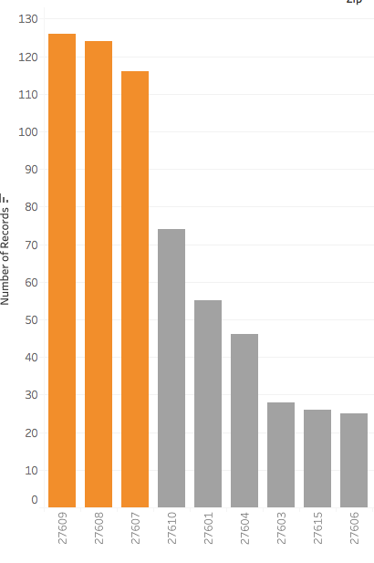

Reorder the bars from largest to smallest clicking on the Y-axis bar chart icon (next to label)

## **Creating a group**

Now highlight the top three zip codes by clicking and dragging a box over them.

When you have highlighted them, right-click on one of the bars and select Group from the dropdown menu

This should create a new group (Zip (group)) and change the color of that group by default.

## **Map**Screen Shot 2016-09-07 at 10.36.17 AM.png

Now we’ll make a map using the grouped data to highlight where the most demolitions occur.

Create a new sheet.

Drag **Longitude** to columns

Drag **Latitude** to rows

Drag **ID** to the Detail button (make sure it’s in Dimensions first)

Drag Zip to the Detail button

Drag Zip (group) to the Color button

Drag Zip (group) to the Filters button. Unselect Other. This will remove all points that are not in the zip codes of the selected group.

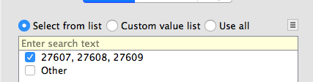

## **Adding map layers**

Go to Map > Layers

In the Data Layer dropdown, add Household Income (median) as layer

Change the color scale to Gray Sequential using the dropdown tab

You can also add streets, highways and borders by checking those boxes under **Map Layers**

**Make sure to add Zip code boundaries, zip code labels and streets and highways**

## **Bins and Calculated Fields**

You can create custom bins in Tableau, which is useful for making histograms and for creating custom color ranges on maps.

We’ll first make the Bins by creating a **Calculated Field**.

In the menu at the top, select **Analysis** then **Create Calculated Field**

Copy and paste this text into the calculated field window:

IF

[Est Project Cost] < 10000 THEN "0 to 9999"

ELSEIF

[Est Project Cost] >= 10000 AND

[Est Project Cost] <= 50000 THEN "10000-50000"

ELSEIF

[Est Project Cost] >50000 THEN ">50000"

END

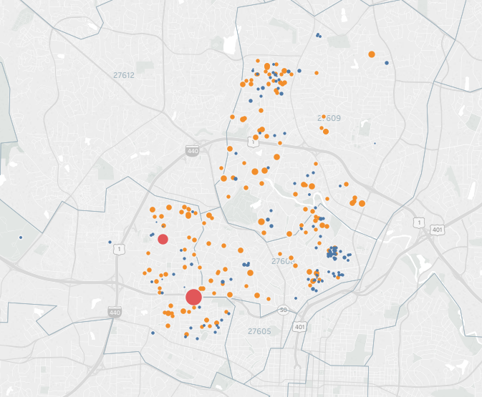

Name the Calculated Field **Calc1**

Drag **Calc1 to Color**

This will color the points on your map according to your bin ranges.

## [**Filtering**](http://onlinehelp.tableau.com/current/pro/online/mac/en-us/filtering.html)

You can filter a sheet, multiple sheets or the entire data source in Tableau.

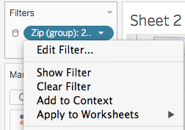

**I. Applying a filter to multiple sheets**

Click on the Zip (group) label dropdown in Filters.

Select “Apply to Worksheets”

Select “All Using this Data Source”

**II. Creating a Data Source Filter**

Data Source filters reduce the data in the data source, which is helpful if your data source is very large and you don’t want to publish it all to the web. It also is useful if you are pulling it in from a database, such as mysql, which you can do using the Tableau Desktop student version.

To filter the data source, right-click (PC), or two-finger click (Mac) on the title of the data source in the upper left column of the page if you are in sheet view.

In the dropdown menu, select **Edit Data Source filters...**

Select Add

Add Census Land Use

Check only DEMOLITION OF RESIDENTIAL DWELLING

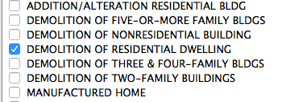

To **remove the data source filter**, click on the data source title and then Edit Data Source filters…

Then select and remove the filter using the Remove button.

## **Intermediate Charting**

**Combination Charts**

Combination charts will allow you to combine chart styles into one view, such as a bar chart and a line chart. This is helpful if you are trying to show a relationship between different kinds of data in one chart. Caution: take special care to make sure your are communicating data clearly. It is harder for people to interpret combination charts quickly.

Let’s make a chart to compare the number of housing units total to project costs over time.

Let’s make a line chart comparing **Est Project Costs** by **Census Land Use** over time.

Under Marks, choose Line from the dropdown

Drag **Est Project Costs** to Rows

Drag **Fiscal Year** to Columns

Drag **Fee** and drop it onto the RIGHT Axis line (a black dotted line on the right side of the chart shoud appear. Drop it there).

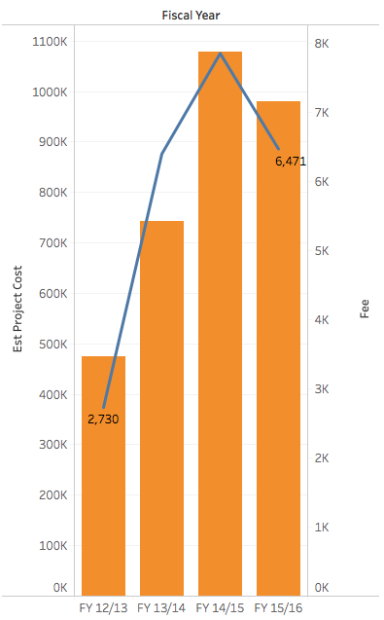

In the Marks card, click on Sum(Fee).

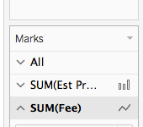

Change chart style to a **Line** chart.

Screen Shot 2016-10-26 at 4.12.26 PM.png

**Labeling Specific Data Points**

Tableau allows you a number of different label options. Here, we will add labels to the line ends for each line. 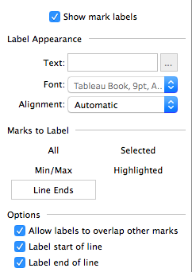

Click the **Label** button in the Marks window

Select the **Line Ends** button

**Making a Quick Table Calculation**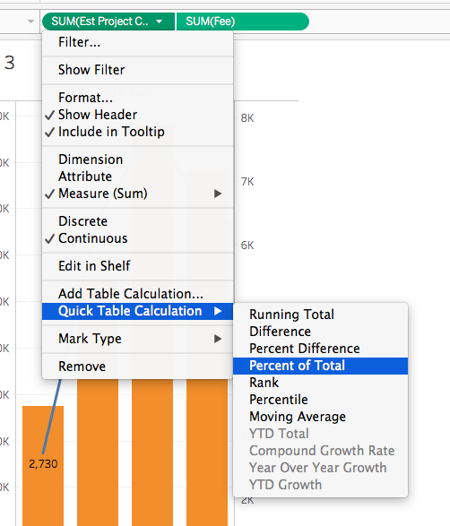

We can do a table calculation on this chart to get additional views that could be helpful with analysis.

Click on the SUM(Est Project Cost) label dropdown in Rows.

Select **Quick Table Calculation**

Select Percent of Total

## 

## 

**Adding a Reference Line**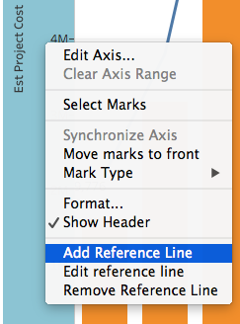

Reference lines help with communicating a message about your data.

Right Click (CTRL click on a Mac) on the **left axis** of the chart.

Select **Add Reference Line**

**Select Median.** This will add a reference line to the chart.